1

Clever Portal Sign in for Students

On a district owned computer (including Chromebook). Please see additional instructions for non-district owned devices.

• Students will log into the computer with their Active Directory credentials (Ex. Username - harrypotter001; Password – whatever they made it). Teachers can reset student passwords at https://portal.cusd.com

• VERY IMPORTANT - Students will need to log off the computer before the next student uses it. One way to do this is to Press Ctrl + Alt + Del and choose the option to Log off. Students can’t just close the browser. If students forget to log off, the next student will have access to the previous student’s accounts.



1. Have students open the Chrome Browser in their device (some Chromebooks start in Chrome automatically).

2. Two tabs will automatically open the first will be the school’s website (or CUSD’s website) and the second on will be the CLEVER portal. Click on the second tab “Log in to Clever”

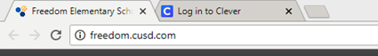

3. Or students will go to clever.cusd.com and click on “Log in with Active Directory”

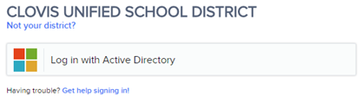
Clever Portal Sign In for Students

2

4. Once in Clever, they will have access to a number of different resources (which can be filtered by school, grade, or teacher).

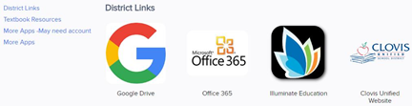
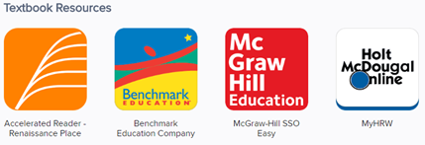
5. Students will be able to click on the icon and it will log them in automatically for some of the resources.
{Examples: Accelerated Reader and Benchmark Education (more coming)}. Other resources will prompt them to enter their password the first time and Clever will save it so they will not have to enter it again.

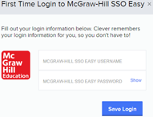
Clever Portal Sign In for Students
3

6. Clever saves the username and password in their application by using the Clever Chrome Extension. Technology is pushing out the extension to all district owned computers. You can tell if your computer has the extension installed by the “blue C” near the address window bar (picture 1). If you don’t have it installed, you will be prompted to install it (picture 2).

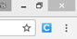
(Picture 1) (Picture 2)

On a student owned computer; iPad; or to logon from home

• Since students don’t log into the computer/iPad with their Active Directory credentials, they will have to enter their username and passwords for each application.

1. Students will go to clever.cusd.com and click on “Log in with Active Directory” (best with the Chrome Browser)

2. Since students don’t log into the computer/iPad with their Active Directory credentials, they may get a page similar to below. Click on “Log In with a different account”. (Or skip to step 3)

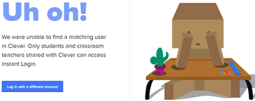
Clever Portal Sign In for Students
4

3. Students will get prompted with the screen below.

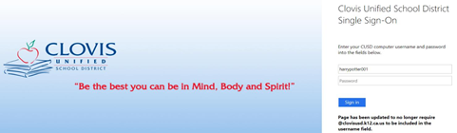
4. Students will enter their Active Directory credentials.

(Ex. Username - harrypotter001; Password – whatever they made it).

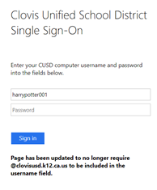
5. Students will click “Sign In” and will be logged into their respective Clever accounts.

Clever Portal Sign In for Students

